

PROPOSAL DOCUMENT

BACKUP AND REPLICATIONS
Johanson IT Solutions T/A
Progressive Data Solutions

06th October 2023
© Sautech (Pty) Ltd. http://www.sautech.net
TABLE OF CONTENTS

1. INTRODUCTION 3
2. MICROSOFT HYPER-V REPLICATIONS 3
3. MICROSOFT HYPER-V Primary Replication 3
4. Primary Replication Failover 3
5. DR Replication Failover 4
6. Backup Failover 4
7. Infrastructure diagram 4

INTRODUCTION

The purpose of this document is to describe the Progressive Data Solutions Replications and Backups, with processes and a how to guides.

MICROSOFT HYPER-V REPLICATIONS

- Progressive Data Solutions has two sets of Replications.
- Primary Replications that acts as a failover within the same Datacentre.
- Secondary Replication (DR) that acts as a failover to a 2nd Datacentre.

MICROSOFT HYPER-V Primary Replication

- Progressive Data Solutions has two servers at MTN Gallo Manor (Afrihost), the Primary and Secondary Server.
- On the Primary Server there are two Virtual Machines which are replicated to the 2nd Server with incrementals of every 15min and total of 24 restore points.

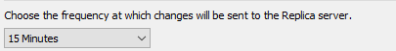

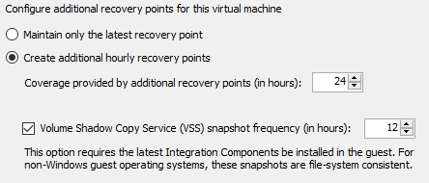

Primary Replication Failover

- Primary Failover will occur if the following applies:
- Virtual Machine Failure
- Windows Updates Failure (which caused Server not to start)
- Application Failure
- Databases Deleted / Corrupted
- Primary Server Failure
- Acting Company Responsible for calling Primary Replication Failover = Sautech

DR Replication Failover

- DR Failover will occur if the following applies:
- MTN Gallo Manor (Afrihost) is completely down
- Primary and Secondary Server complete Failure
- Additional conditions apply for calling DR Replication Failover:
- Progressive Data Solutions DR policy should be in effect and active
- DR Failover will occur in a certain period that is stipulated in the DR policy of Progressive Data Solutions
- When there is no way of restoring the Primary Services within the time frame of the DR policy of Progressive Data Solutions
- Acting Company Responsible for calling DR Replication Failover = Progressive Data Solutions

Backup Failover

- Backup Failover will occur if the following applies:
- All data is missing exceeding the time frame of available Primary and DR Replications
- Data Encryption with all Primary and DR replications infected
- Acting Company Responsible for calling DR Replication Failover = Progressive Data Solutions

Infrastructure diagram

